Advisory form about taking care of BSH and BLH kitten s
Cattery Evjana Anjero and Next Page
Breeders of British shorthair and British longhairs

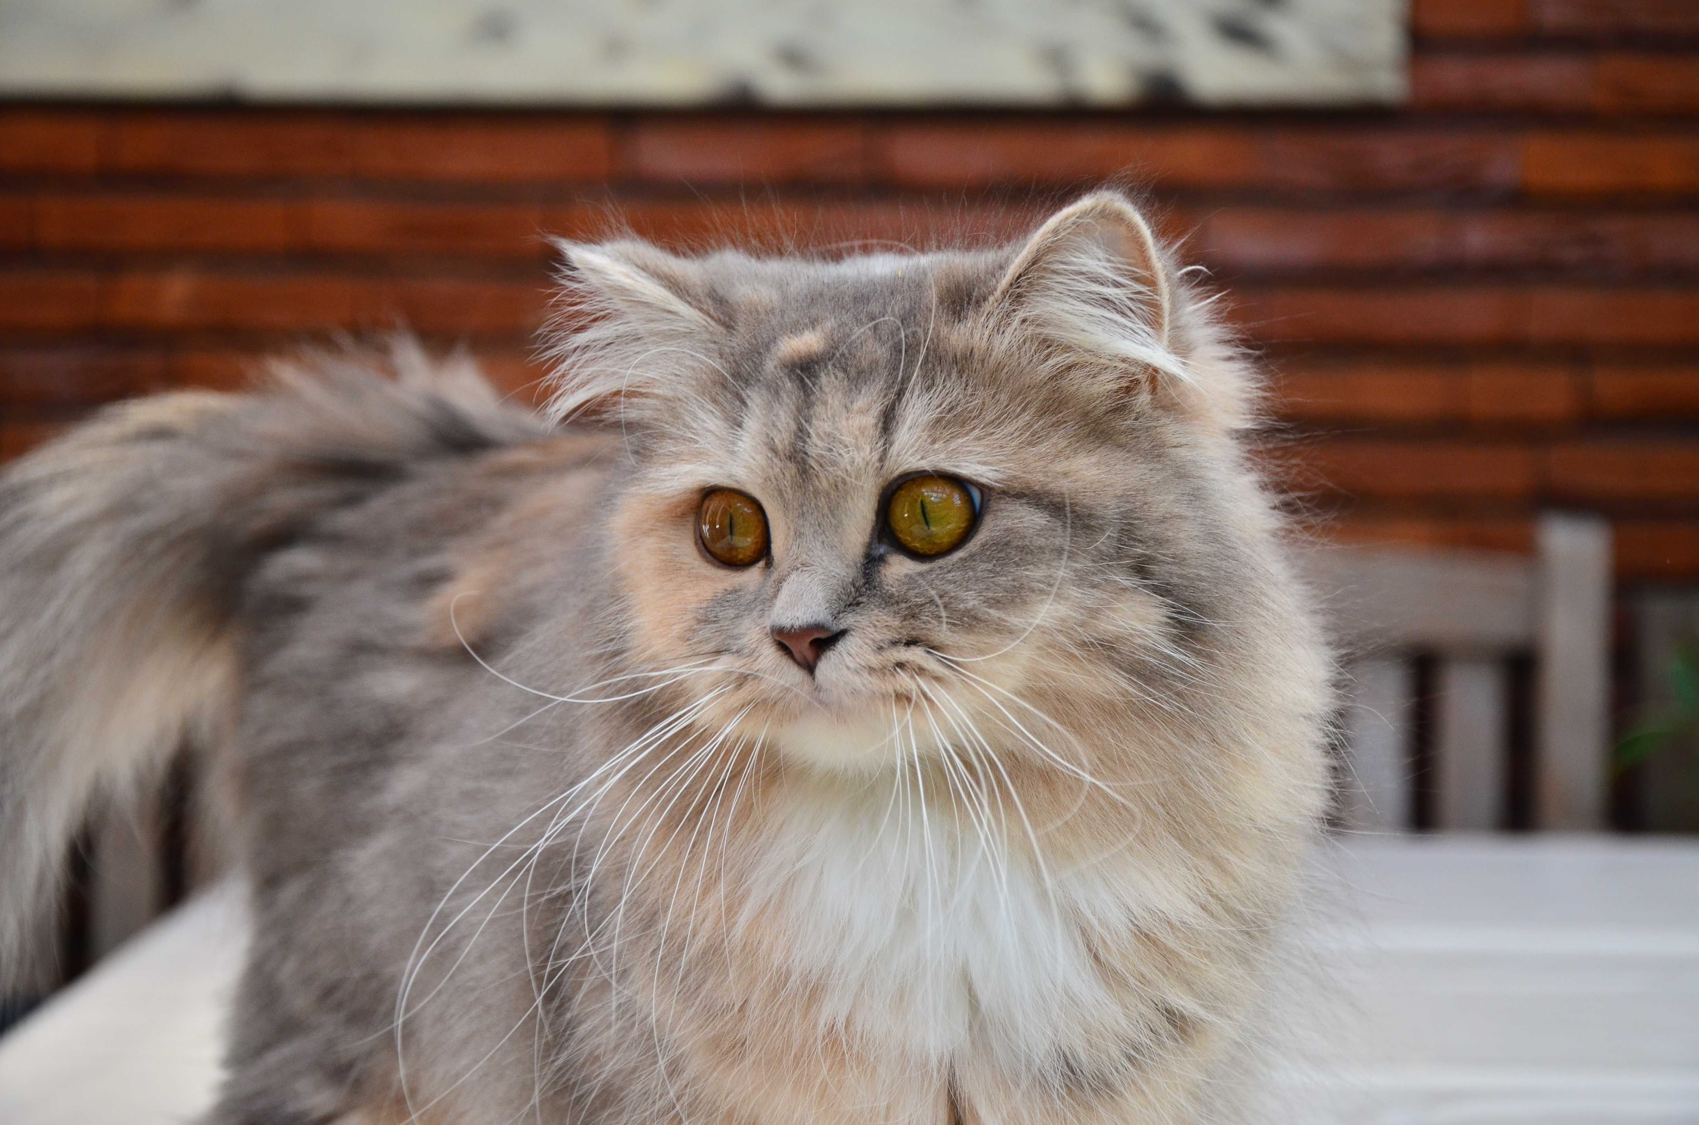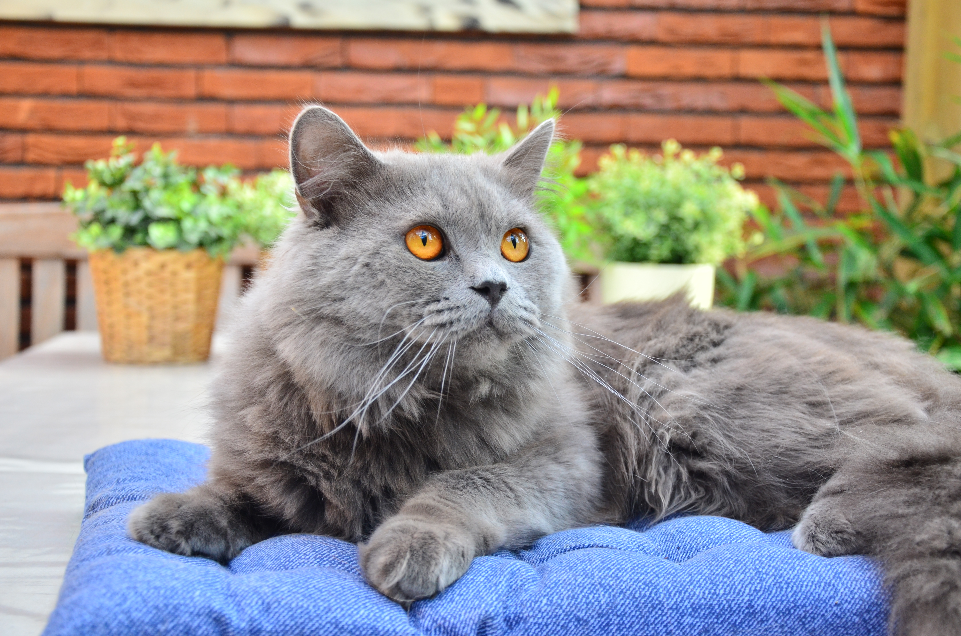

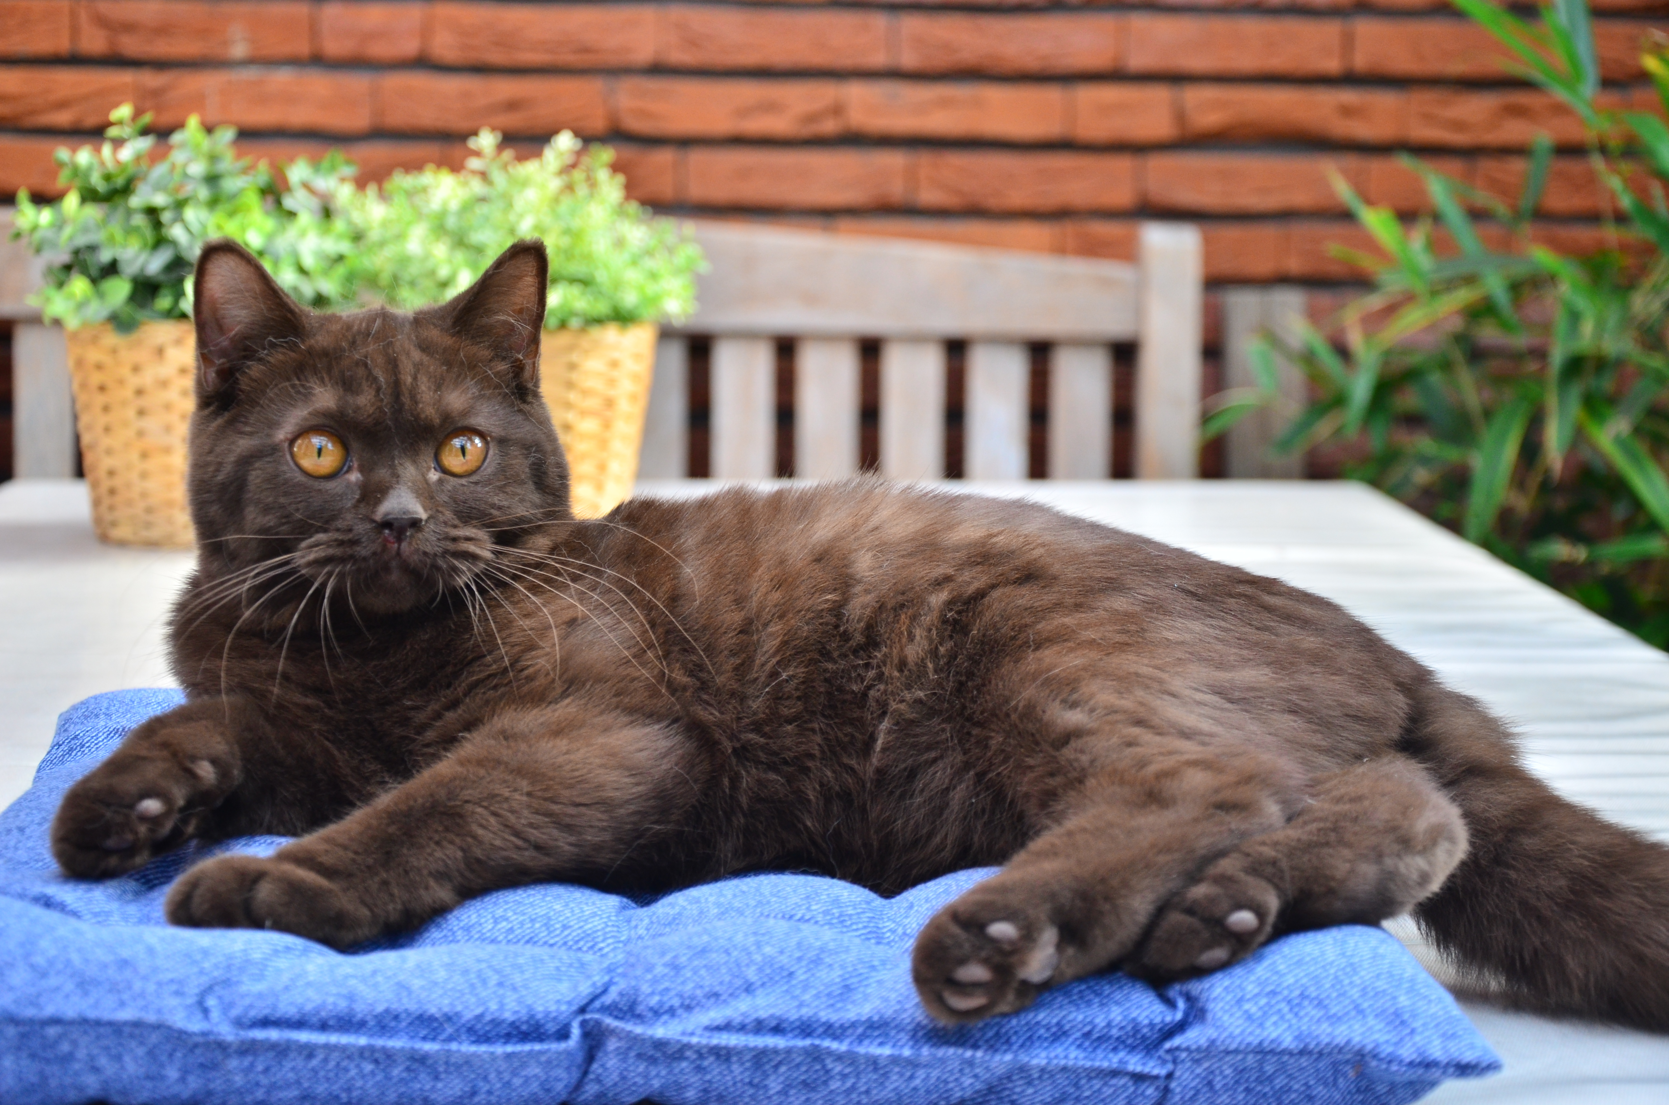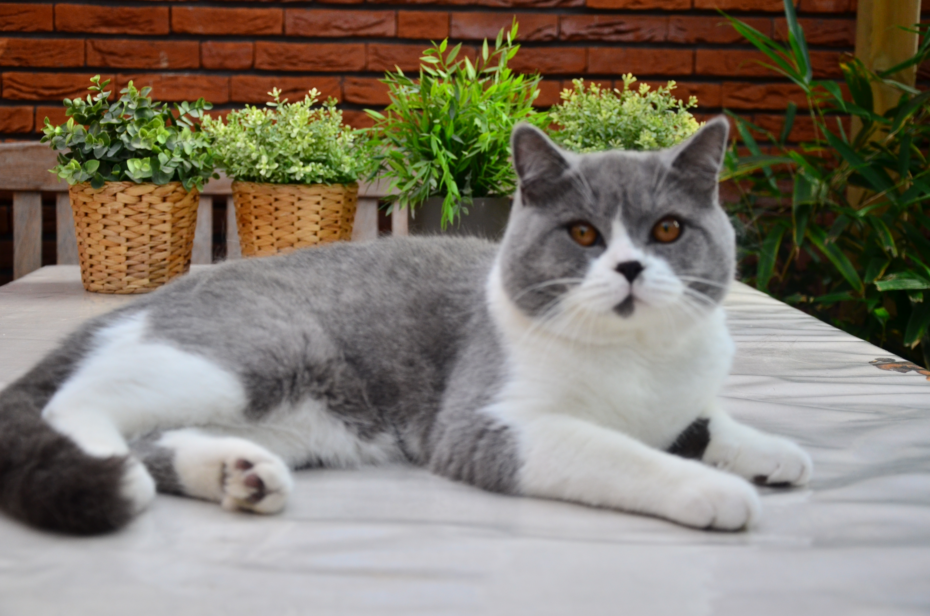

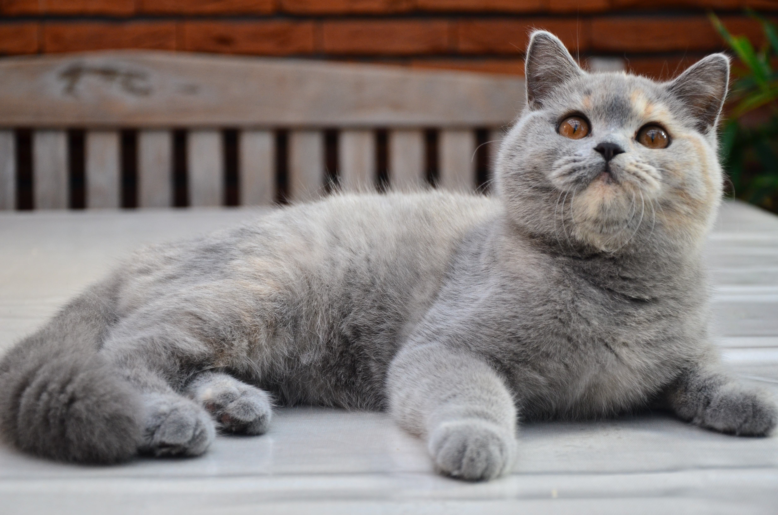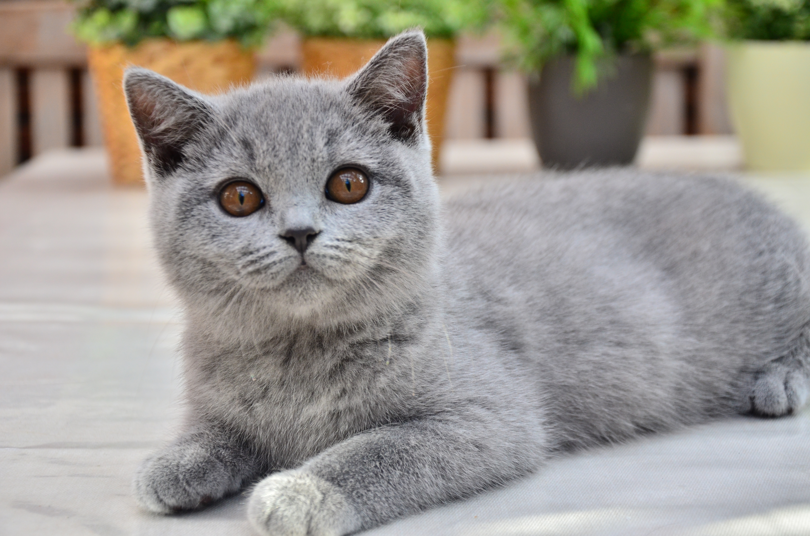

Tests parents:
The kitten was born from HCM and PKD free parents, which were tested by DNA or by echography.
Also in the line of the parents no genetic form of Patella Luxus was present.
The kitten is investigated by the veterinarian and is completly healthy.

Tin food:
The first 4 months the kitten should have good tin food, especially for cats, on regulary basis as of 2-3 times a day. Between the 4th and 6th month 2 times a day suits and after this period you can give the cat once a day. After one year it is sufficient as an extra.
The breeder tells you what kind of food can be given.
If too much tin food will be given periodontal disease can occur.

Till the age of 6 months it is necessary that enough RC BSH kitten is available. In these hard cat food enough nutrients are available for the kitten for growth en health. The other kind of manufactors have mostly too much salt in there cat food what can cause damages in kidney and blather. Veterinarian control should be taken and also special food and veterinarian costs will rise.

Be aware that enough fresh water is available and that should be refreshed two times a day. We advice to buy a special reservoir with a filter system that only should be cleaned every week. Wash out and fill the reservoir with fresh water.

If your kitten is half a year then you can switch over to a mixture of RC BSH kitten and RC BSH adult. When the kitten is 10 months a complete switch to RC BSH adult is necessary. If the kitten is a British longhair also a mixture of RC BSH adult and RC Hair & Skin can be used. For the fur it is very good for nutrient to the hairs. Also the burdocks will be less. Combing the hairs will be a lot better.

Deworming:
The kittens will be dewormed by the breeder when they are 3, 7, 9 and 11 weeks. When they are 4, 5 and 6 months deworming should be done by the owner and from 6 months every half a year.

Problems with the intestines:
If problems with the intestines occurs the best is to visit the veterianarian. Sometimes the scour can easely treated, but sometimes it is necessary to give antibiotics.

Fur:
Combing the fur is necessary. The old hairs will be removed and also the burdocks can be removed easily. For the shorthairs this can be done every 2 weeks and for the longhairs once or twice a week.
The kitten you will take away is completely combed.

Fleas:
A pipette with liquid to destroy the fleas is preventative given. Visitor scan bring in flea eggs under the shoes and so a flea calamity can occur in the house. The best is to repaet this treatment every half a year in the known periodes (spring and autumn).

Nails:
Cutting the nails can be done every month with a special scissers. The scissers can be obtaine via internet or your special animal store provides this equipment.

Castration:
Castration of the male can be done after when he is 8 months or when his urine smell different then usual. Most of the times it is better to do this when he is older. This only is positive for a better growth of the cat. When it suits you make an appointment with your veterinarian to set the date.

Sterilization:
Sterilization of the female can be done the best after the first rutting period. The best is after the 10th month after birth. Make an appointment with your veterinarian to set a date.

Vaccination:
Vaccination is necessary every year till the cat is 4 years. After this it suits every 2 years and after when the cat us 10 years no further vaccination is necessary because enough antibodies are present.

Pet insurance:
If no extra finances are present it could be an advice to have a pet insurance if this available in the country. Otherwise be prepared to save some extra finances for unforeseen extra costs. (Proteq, Hema and Reaal Dier en Zorg (Reaal dier en Zorg), Petplan (https://www.petplan.nl/) of bij de Hema (www.dierenverzekeringen.org/hema/).

Young cats can you teach and unteach a lot. It is important that enough attention will be given to build trust for as well the owner as well as the cat.
Take well care to the cat and hug them as many as possible. The one will be done easily and it takes some time with the other. Still it can be learned that the cat likes the hugs.

If you will take once a while a picture from your cat it pleasures us very well. Maybe we can use the photograph for the website and can we see how the cat grows.

A lot of pleasure with your new room mate.

--------------------------------------------------------------------------------------
Cattery “Evjana Anjero” and Cattery “Next Page”.
Evert Jan en Nancy Greven-Wester
Pruimenboomplein 11
1971 RE Ijmuiden, The Netherlands
+31 (0) 255755458
+31 (0) 651418890
roselinewester@gmail.com
--------------------------------------------------------------------------------------

